## INTRODUCTION

Life is lived via optimization. All of us want to make the most of our limited time and resources. Everything uses optimization, from making the most of your time to fixing supply chain issues for your business. In data science, the subject is particularly fascinating and important.

One of the most basic techniques for optimization is linear programming (LP). By adopting a few simplifying assumptions, it aids in the resolution of certain extremely challenging optimization issues. Linear programming (LP) is a specific kind of technique used for economically allocating "scarce" or "limited" resources, such as labor, material, machine, time, warehouse space, capital, energy, etc. to several competing activities, such as products, services, jobs, new equipment, projects, etc. on the basis of a given criterion of efficiency.

**Importance of Linear Programming**

The benefits of linear programming are as follows (Maiti A., 2021):

* Linear programming assists in maximizing the utilization of beneficial resources. It also shows how choosing and arranging these resources may help a decision-maker use his productive factors efficiently.
* Techniques for linear programming enhance the standard of decisions. The user of this strategy adopts a more objective and less subjective decision-making process.
* Linear programming approaches provide potential and workable solutions since it's probable that there are external limitations at play that need to be taken into consideration. The fact that we can create a lot of units does not guarantee that they will sell. For the ease of the decision-maker, it is therefore essential to modify the mathematical answer.

## PROBLEM STATEMENT

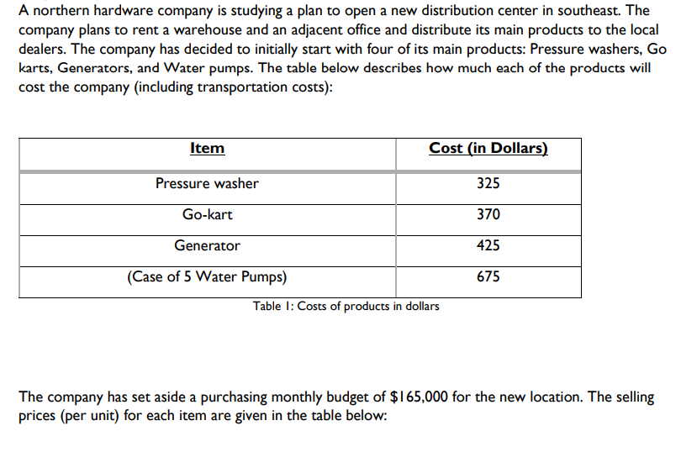

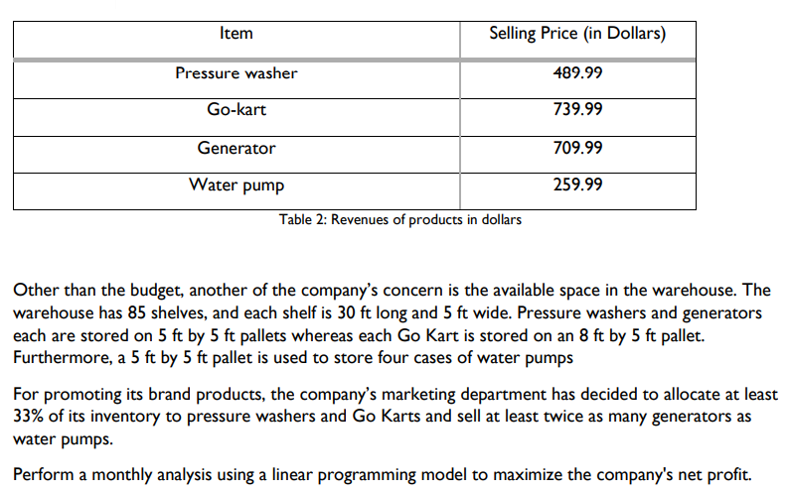

## ANALYSIS

## (1) Formulation of the mathematical problem in linear programming that we will utilize for this model.

These are the decision variable that we are using for this model.

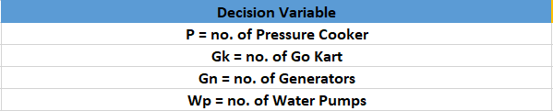

As are we working on a maximization model, we will be using Ax <= b and therefore the objective for our model will be:

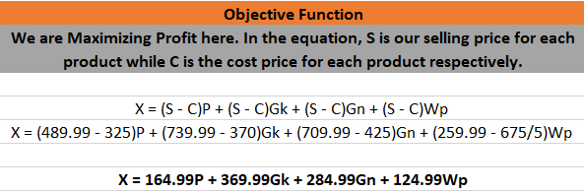

Finally, we are going to present the constraints for this model:

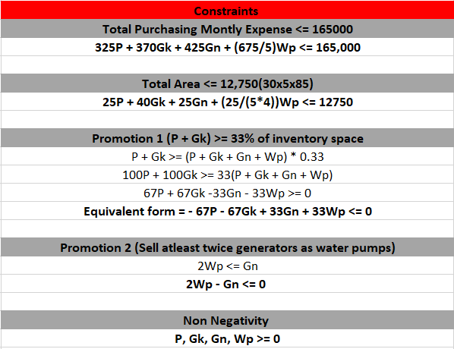

We will finally offer the mathematical formulation for our linear programming model after obtaining the decision variable, objective, and constraints:

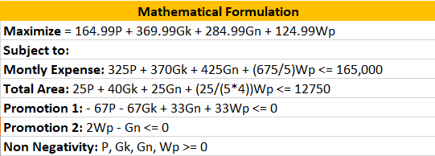

## (2) Based on the results of the previous task, setting up the linear programming model. And using Solver to get the optimum solution.

Based on the maximization equation we set up our objective parameters with respective to the decision variable.

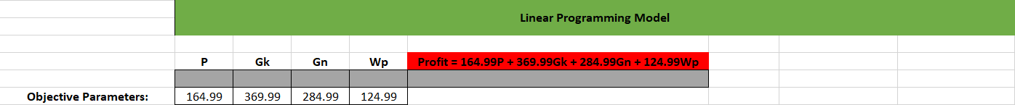

We also created a table for the constraints on this model and created a separated to column to present the unused resource.

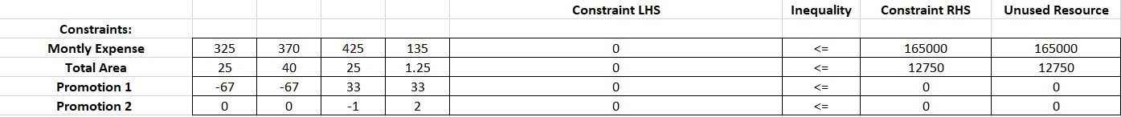

Finally, are presenting the table we will use the help of the Solver to calculate the optimized Decision and Objective value with respect to their constraints.

## (3) Generating Sensitivity report for this model.

## 

Keeping the other per unit fixed at 369.99, 284.99 and 124.99, as long as this profit is between -1E + 30 & 271.7796, the optimal decision solution does not change. Which means my decision variable values won't change if they are in this range.

Keeping the other per unit fixed at 164.99, 284.99 and 124.99, as long as this profit is between -261.0547 & 542.4156, the optimal decision solution does not change. Which means my decision variable values won't change if they are in this range.

We can obtain similar results for other decision variables as well just by following the same process of getting the range for each decision variable.

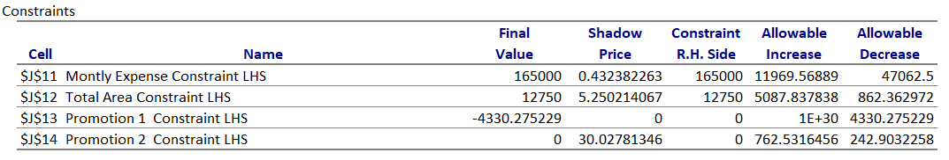

A shadow price is the marginal contribution (this means per unit contribution) of the resource to the optimal profit.

For an addition $ of monthly expense, the optimal profit will increase by about $0.43. This observation is valid as long the available expense is between 117937.5 & 176969.6

For an addition total area unit, the optimal profit will increase by about $5.25. This observation is valid as long the available area unit is between 11887.64 & 17837.84.

Resource with higher shadow price should be added because it will have a higher contribution to the optimal profit. Therefore, choosing total area over monthly expense should be a better option.

## (4) Generating Optimal solution to maximize profit based on the inventory level of the products.

Here are the results we achieved after using the solver

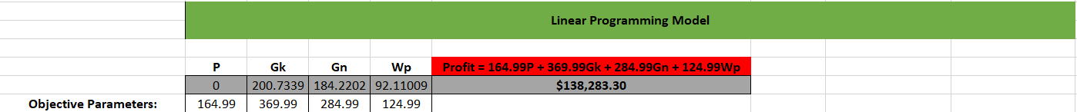

Based on the following constraints.

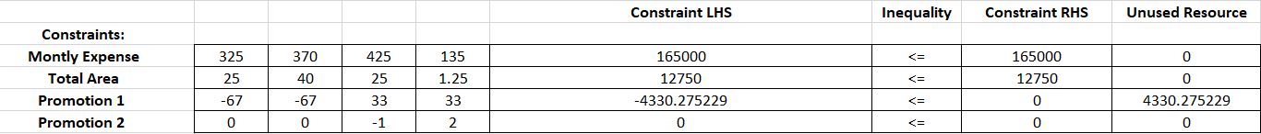

As a result of utilizing the Solver, we can see that the maximum monthly profit we can make depending on the inventory of all four goods is $138283.30. (Pressure Washer, Go Kart, Generator and Water Pump). The optimum inventory product/Decision variable values for each Pressure Washer, Go Kart, Generator, and Water Pump came out to be 0, 200.73, 184.22, and 92.11, respectively.

## (5) The ideal value for one of the choice variables is zero. Find the least selling price for that product using the Solver sensitivity report to alter this optimal zero solution value to a non-zero value.

By looking at the sensitivity reported generated by the solver we can notice that:

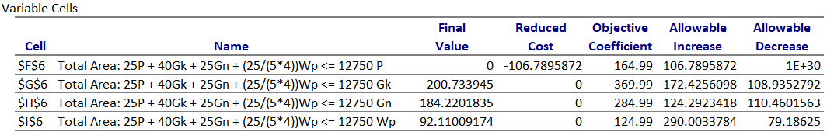

If we keep the other per unit fixed at 369.99, 284.99 and 124.99, as long as this profit is between -1E + 30 & 271.7796, the optimal decision solution does not change. Which means my decision variable values won't change if they are in this range.

Therefore, as long as the range is between -1E + 30 & 271.7796, assuming all other values stay the same. The best course of action still be to have 0 pressure washers.

In this case -1E + 30 is negative infinity. So, if we want to sell pressure washers we need to exceed from the range and we can sell pressure washers for the least selling price > 271.7796.

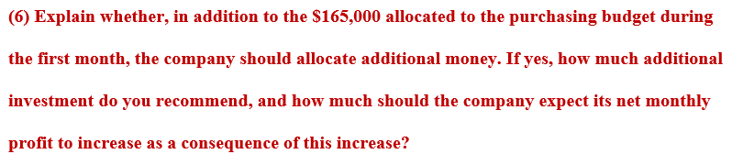

By looking at our constraints table we can notice:

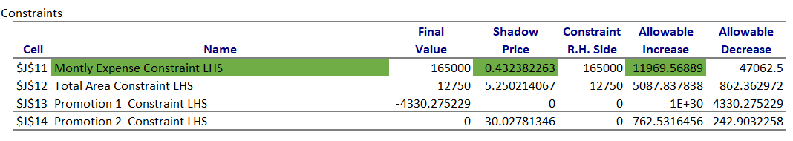

That the shadow price for monthly expense comes out to be 0.432. The allowable increase is 11969.568 which means that after that for an addition $ of monthly expense, the optimal profit will increase by about $0.43. This observation is valid as long the available expense is between 117937.5 & 176969.6.

Therefore, if we increase the monthly expense from $165000 to $176969.6, we will only see a rise to $5170.85 which is not optimum as we will be paying more and getting less total profit.

In view of the fact that we make $0.43 in profit for every dollar we increase the budget, the corporation shouldn't allocate any additional funds. Therefore, it is not advised to increase the budget.

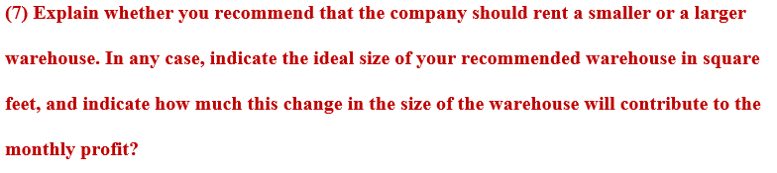By looking at our constraints table we can notice:

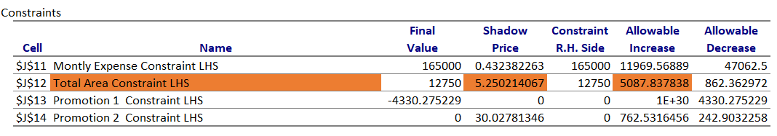

The shadow price for total area comes out to be 5.25. The allowable increase is 5087.837 which means that for an addition total area unit, the optimal profit will increase by about $5.25. This observation is valid as long the available area unit is between 11887.64 & 17837.84.

Therefore, if we increase the total area from 12750ft to 17837.84ft, we will increase the maximum profit by $26,711.15. Making it a total of $164995.54 optimum maximum profit. Increasing the area more after 17837.84ft, we have to redo the table as it will exceed the sensitivity analysis range.

So, my recommendation to the company is that they should rent a larger warehouse for their inventory storage.

## CONCLUSION

Finally, I gained knowledge about linear programming and how to apply it to the real world to develop an inventory management optimization model while working on this report. Along with inventory management, I also gained knowledge of financial modeling, diet planning, and stock investing. In order to put up this optimization model, I learned what decision variables, uncontrolled variables, and constraints are in linear programming. I also learned how to create sensitivity reports for this model and how to interpret them so that recommendations can be made based on them. For example, I now know how to interpret how much we can increase and decrease the variables' and constraints' allowable increases and decreases, as well as how to calculate shadow prices that can increase revenue or decrease expense. I also learnt how to use the lpSolve library in R to generate this same model and sensitivity analysis report.

## BIBLIOGRAPHY

1) Maiti, A. (2021, December 16). *Elements of a Linear Programming Problem (LPP) - Towards Data Science*. Medium. https://towardsdatascience.com/elements-of-a-linear-programming-problem-lpp-325075688c18

2) LP with Solver. (2016). Sfsau. http://faculty.sfasu.edu/fisherwarre/lp_solver.html

3) Goh, B. C., PhD. (2019, February 1). Solve problems with linear programming and Excel. FM Magazine. https://www.fm-magazine.com/issues/2019/feb/linear-programming-microsoft-excel.html

4) Thakur, M. (2021, April 27). Linear Programming in Excel. EDUCBA. https://www.educba.com/linear-programming-in-excel/